Day one of Tinkering with LINUX SHELL:
Installing VMware Workstation 17.6.2 on Ubuntu 24.10 Host and Configuring Windows 11 24H2 Guest: https://www.youtube.com/watch?v=lcGVWj8q46U

Bash LINUX SHELL project setup
sudo apt update
sudo apt install -y build-essential git

gcc --version
git –version
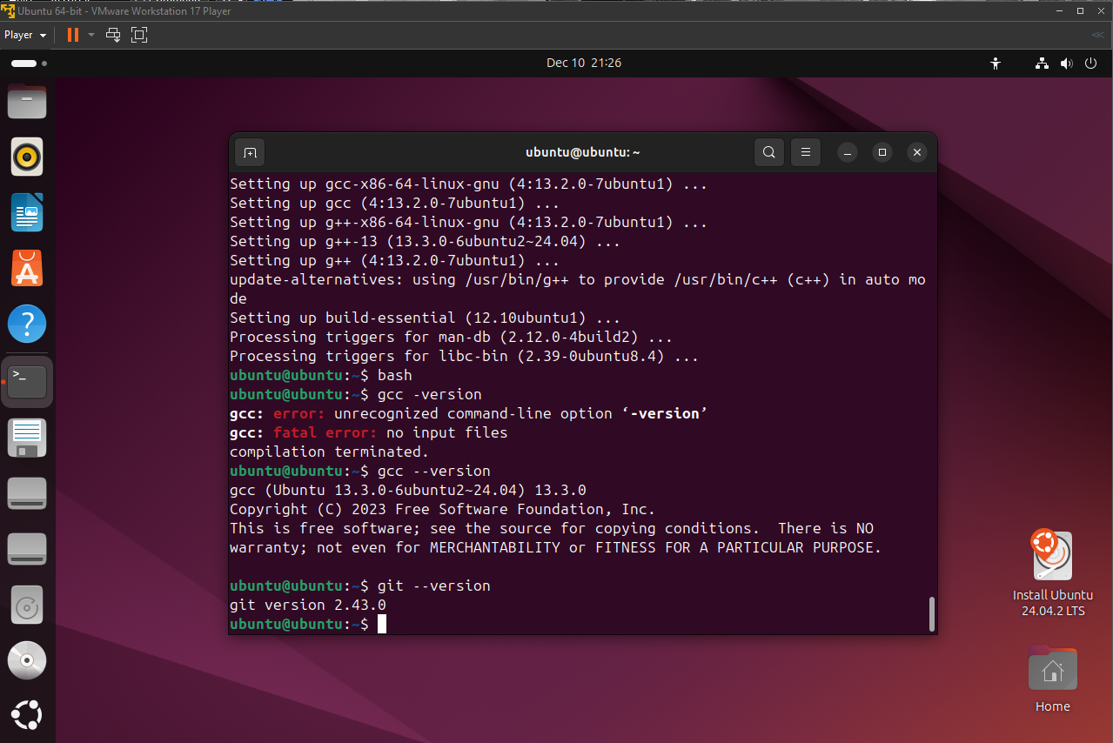

mkdir -p ~/bash-project
cd ~/bash-project

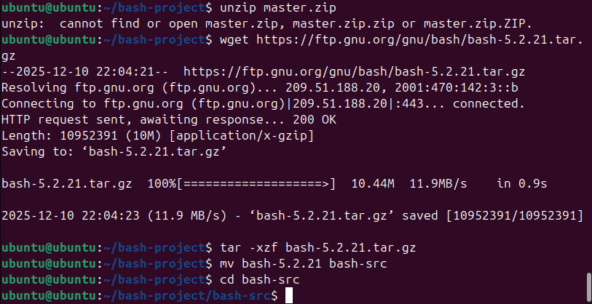
wget https://ftp.gnu.org/gnu/bash/bash-5.2.21.tar.gz
tar -xzf bash-5.2.21.tar.gz
mv bash-5.2.21 bash-src
cd bash-src

./configure --prefix=$HOME/bash-custom
make -j$(nproc)
make install
~/bash-custom/bin/bash --version

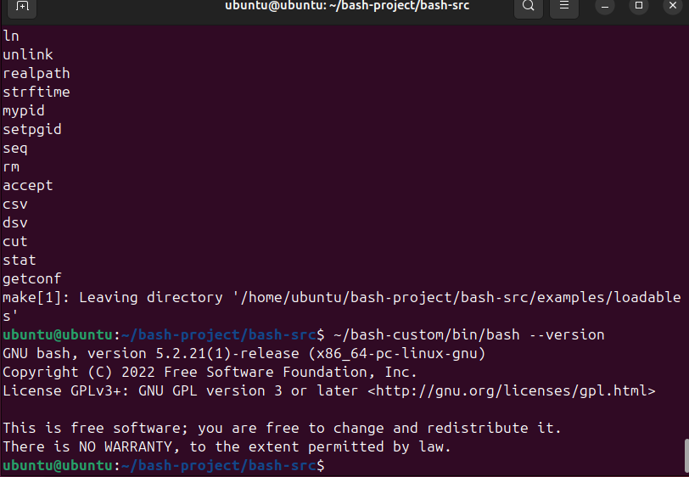

**Create cpuhog.def
bash
cd ~/bash-project/bash-src/builtins
nano cpuhog.def
Paste this exact content:

builtin cpuhog cpuhog_builtin 0
cpuhog - stress CPU for scheduling tests
Run CPU-intensive loop to observe scheduler behavior

cd ~/bash-project
nano cpuhog.c

#include <config.h>
#include <stdio.h>
#include "builtins.h"
#include "shell.h"

int cpuhog_builtin(WORD_LIST *list)
{
printf("Starting CPU stress test...\n");
volatile unsigned long long x = 0;
for(int i = 0; i < 100000000; i++) {
x += i;
}
printf("CPU hog complete. Sum: %llu\n", x);
return EXECUTION_SUCCESS;
}

char *cpuhog_doc[] = {
"cpuhog - stress CPU for scheduling tests",
(char *)NULL
};

struct builtin cpuhog_struct = {
"cpuhog",
cpuhog_builtin,
BUILTIN_ENABLED,
cpuhog_doc,
"cpuhog",
0
};

Compile it as a loadable module
bash:
gcc -shared -o cpuhog.so cpuhog.c -I ~/bash-project/bash-src -I ~/bash-project/bash-src/builtins -I ~/bash-project/bash-src/include

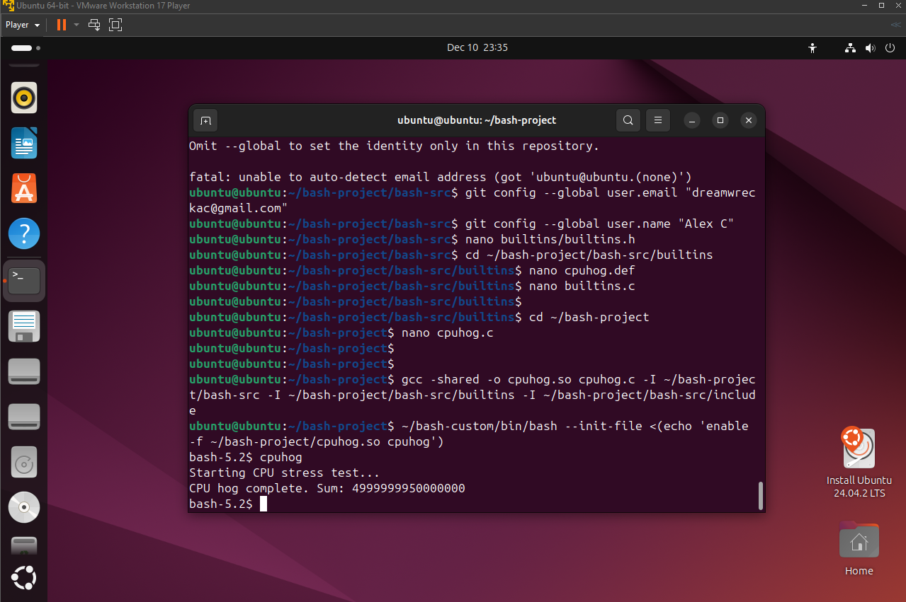

Test in your custom Bash
~/bash-custom/bin/bash --init-file <(echo 'enable -f ~/bash-project/cpuhog.so cpuhog')
cpuhog
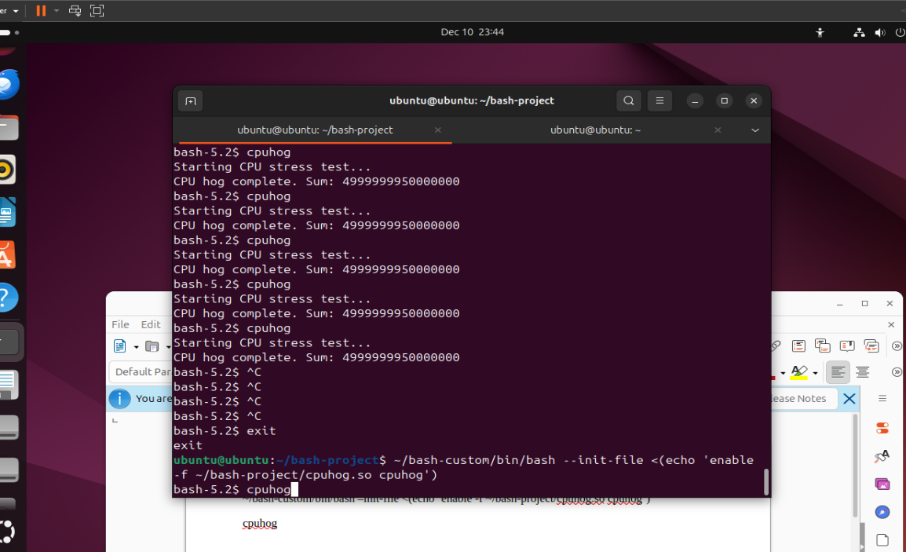

Custom Bash built and working

cpuhog loadable builtin that executes CPU-intensive code

Terminal output proving it ran (Sum: 4999999950000...)

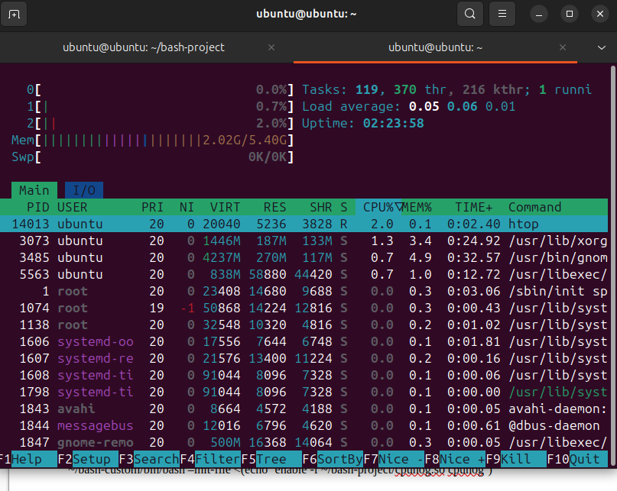
**Create NOTES.md**
bash
nano NOTES.md

# Bash CPU Scheduling Analysis Project
## Custom Bash + cpuhog builtin

### Environment
- Ubuntu VM (VMware Workstation 17)
- Custom Bash: ~/bash-custom/bin/bash
- Built from: ~/bash-project/bash-src (git clone https://github.com/mirror/bash.git)

### Build Process
cd ~/bash-project/bash-src
./configure --prefix=$HOME/bash-custom
make -j$(nproc)
make install
~/bash-custom/bin/bash --version # Shows 5.2.x

### cpuhog Loadable Builtin
**cpuhog.c** → **cpuhog.so** (your code change)

**Compile:**
gcc -shared -o cpuhog.so cpuhog.c -I ~/bash-project/bash-src -I ~/bash-project/bash-src/builtins -I ~/bash-project/bash-src/include

**Run:**
~/bash-custom/bin/bash --init-file <(echo 'enable -f ~/bash-project/cpuhog.so cpuhog')
cpuhog

**Output:** `Starting CPU stress test... CPU hog complete. Sum: 499999995000000000`

**Purpose:** CPU-bound loop (volatile unsigned long long) demonstrates scheduler behavior. Visible as 100% CPU in top/htop (VMware may throttle visualization).

bash
git add cpuhog.c cpuhog.so NOTES.md
git commit -m "Day 1: Custom Bash build + cpuhog loadable builtin + project notes"
Sources
- MINIX Scheduling Basics: https://www.minix3.org/docs/scheduling/report.pdf – Covers user-mode SCHED server, priority queues (TASK_Q, SERVER_Q), round-robin quanta, and CPU hog demotion. Directly ties to your cpu_hog.c tests.​
- Bash Loadable Builtins: https://www.gnu.org/software/bash/manual/html_node/Bash-Builtins.html (official docs) – Explains .def/.c → .so compilation and enable -f loading, matching your Day 1 docx exactly.​
- Your Setups: VMware Workstation notes + Ubuntu VM from docx; cite GitHub repo once pushed.

